Homework: Multiple choice questions

Sequencing

Q1. Which one of the following segments of code would be the most precise block to use to draw a blue square in Scratch.

A | 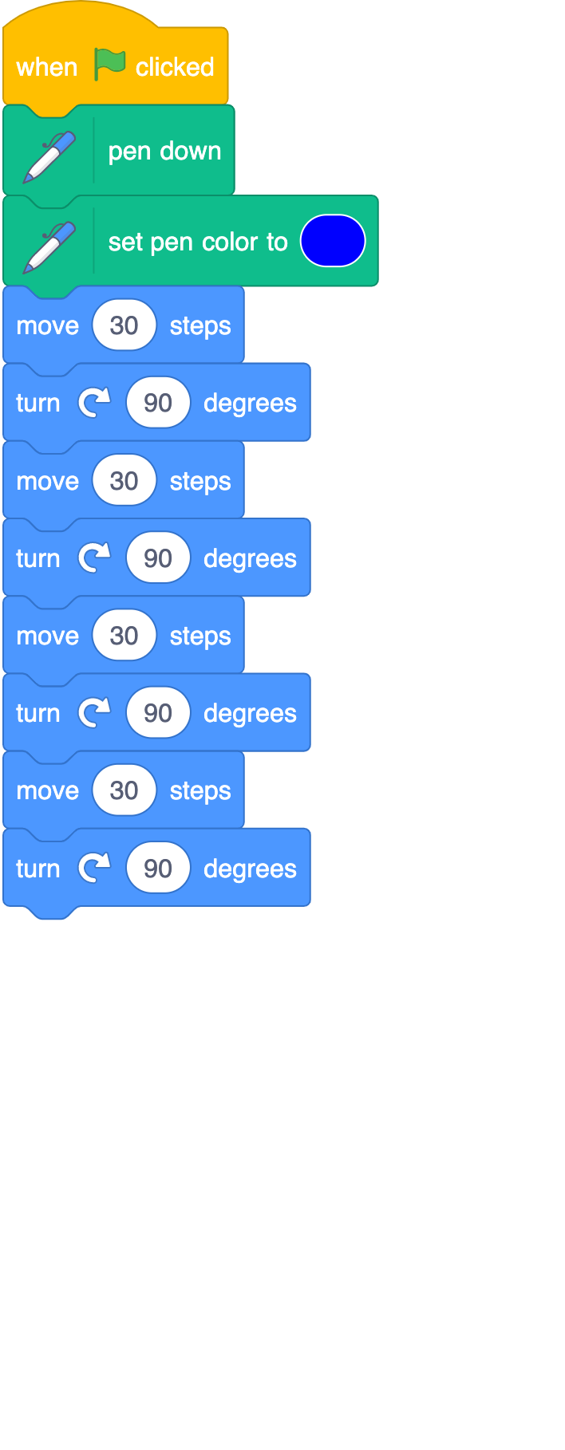 | B | 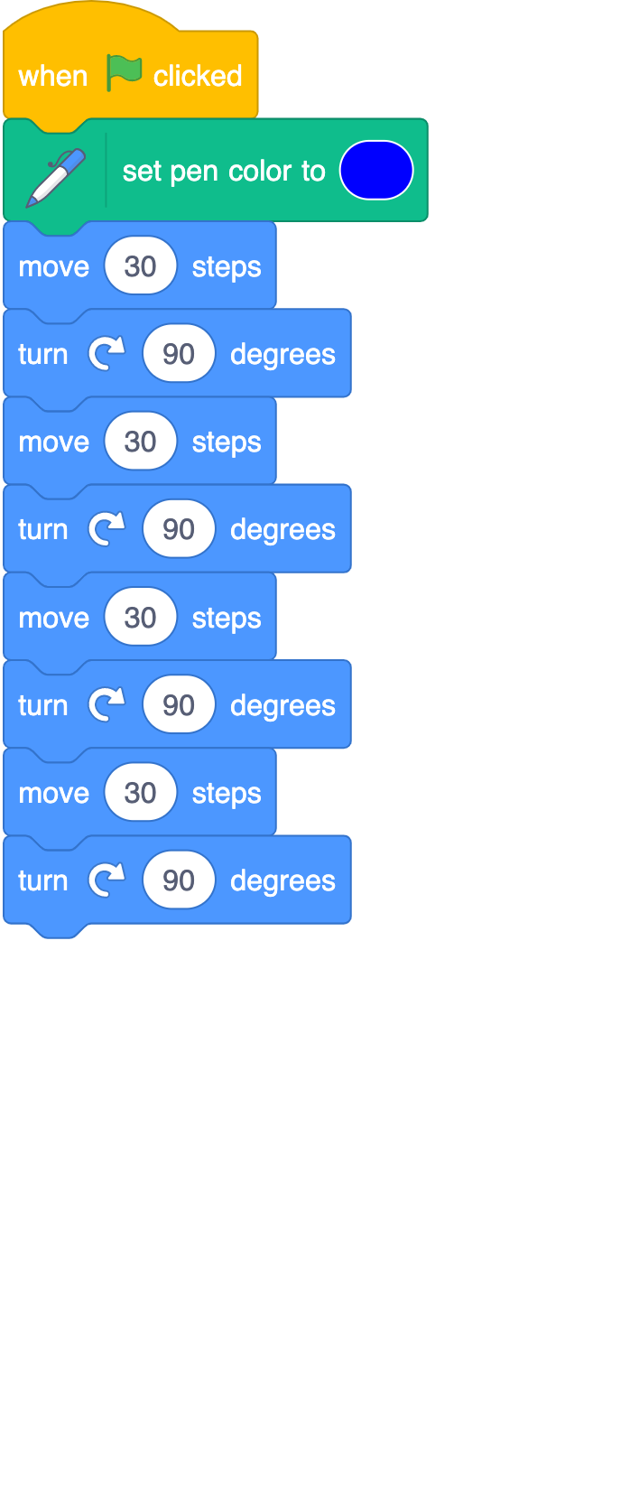
C | 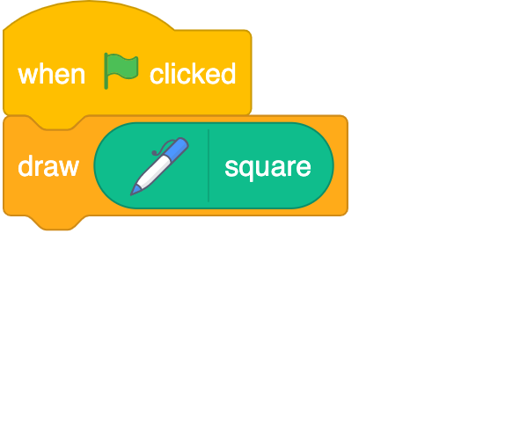 | D | 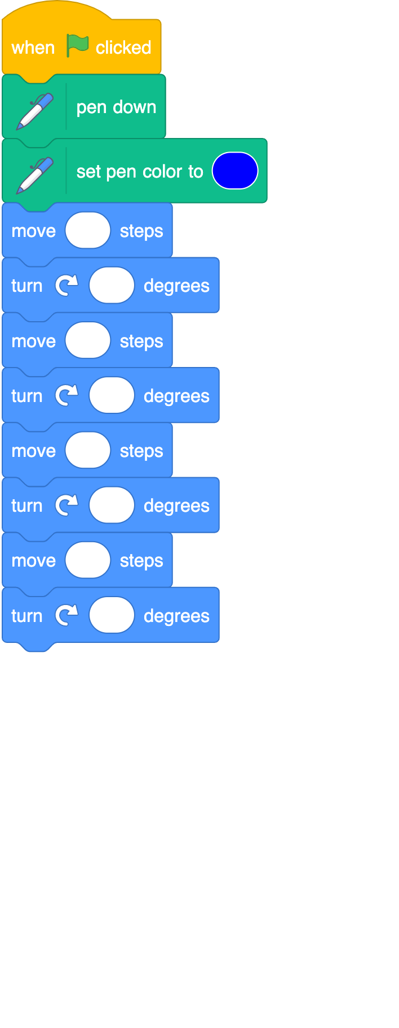

Answer
Justification

Q2. Would the following program correctly play the nursery rhyme, Hot Cross Buns?

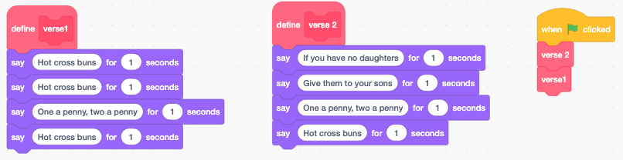

Answer
Justification

Variables
Q3. What would the output of Say weather be at the end of this program?

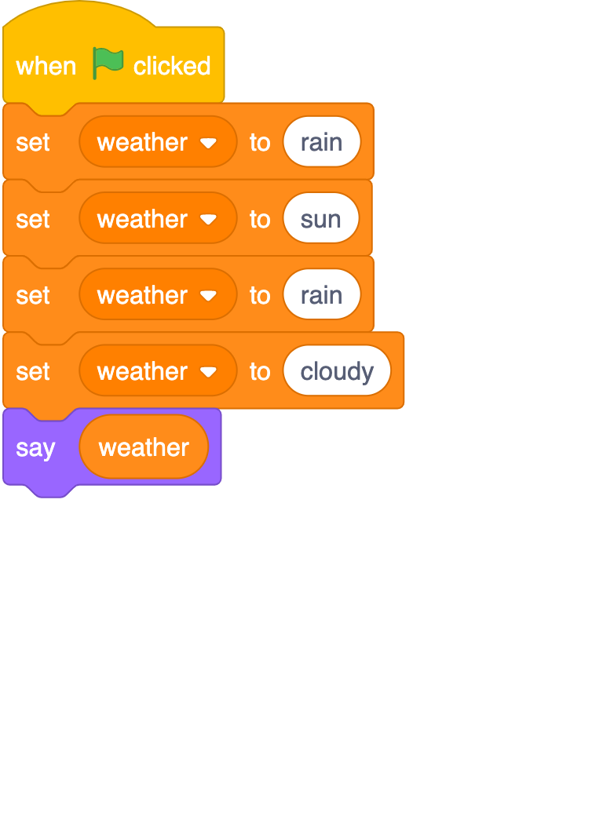 | A rain  B cloudy  C rain, sun, rain, cloudy  D weather

Answer
Justification
Q4. What value would be held by the ‘name1’ variable and the ‘name2’ variable at the end of this program?

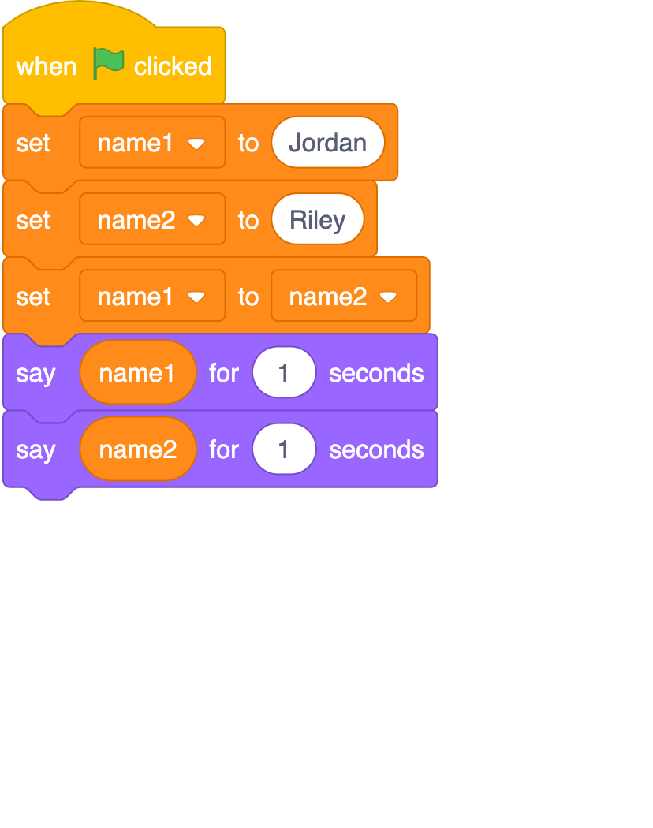 | A name1 = Jordan name2 = Riley  B name1 = Riley name2 = Jordan  C name1 = Jordan name2 = Jordan  D name1 = Riley name2 = Riley

Answer
Justification

END OF QUESTIONS

Resources are updated regularly — the latest version is available at: ncce.io/tcc.

This resource is licensed under the Open Government Licence, version 3. For more information on this licence, see ncce.io/ogl.

